# Set up disaster recovery to a secondary Azure region for an Azure VM

## Enable replication for the Azure VM

1. In the Azure portal, click **Virtual machines**, and select the VM you want to replicate.
2. In **Operations**, click **Disaster recovery**.
3. In **Configure disaster recovery** > **Target region** select the target region to which you'll replicate.
4. For this Quickstart, accept the other default settings.
5. Click **Enable replication**. This starts a job to enable replication for the VM.

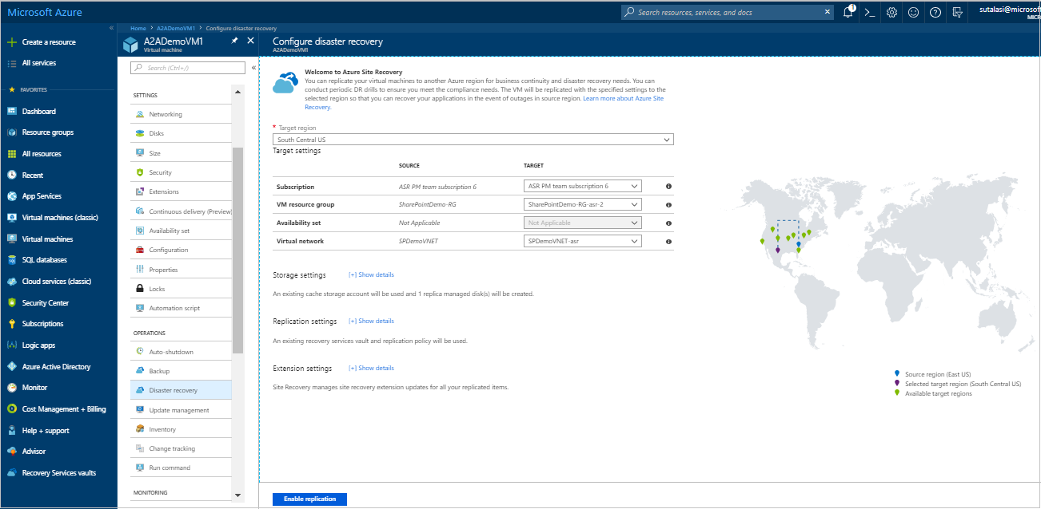

## Verify settings

After the replication job has finished, you can check the replication status, modify replication settings, and test the deployment.

1. In **Operations**, click **Disaster recovery**.
2. You can verify replication health, the recovery points that have been created, and source, target regions on the map.

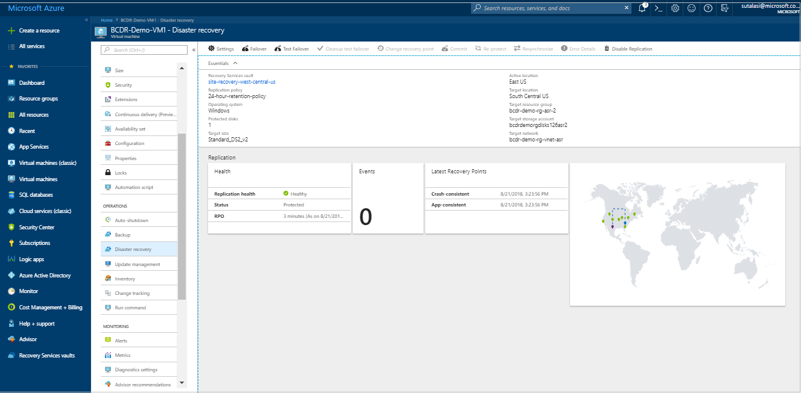

## Clean up resources

The VM in the primary region stops replicating when you disable replication for it:

* The source replication settings are cleaned up automatically. The Site Recovery extension installed on the VM as part of the replication isn't removed, and must be removed manually.
* Site Recovery billing for the VM stops.

Stop replication as follows

1. Select the VM.
2. In **Disaster recovery**, click **Disable Replication**.

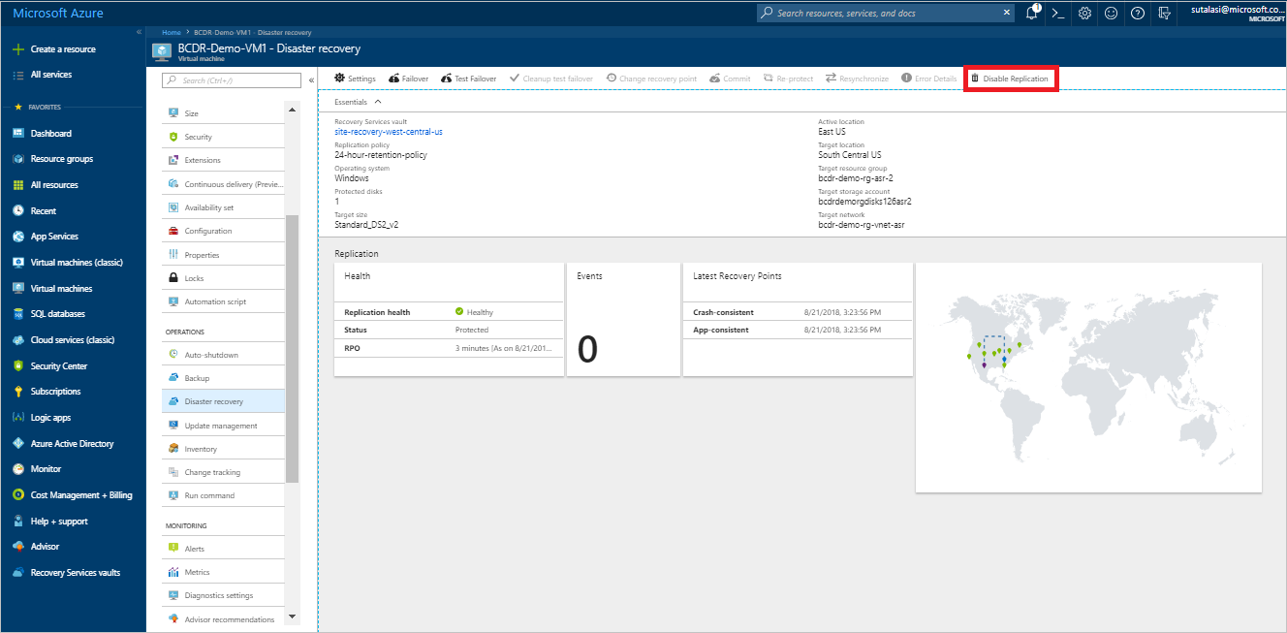

**Set up disaster recovery for Azure VMs**

The [Azure Site Recovery](https://docs.microsoft.com/en-us/azure/site-recovery/site-recovery-overview) service contributes to your disaster recovery strategy by managing and orchestrating replication, failover, and failback of on-premises machines and Azure virtual machines (VMs).

This tutorial shows you how to set up disaster recovery for Azure VMs by replicating them from one Azure region to another. In this tutorial, you learn how to:

* Create a Recovery Services vault
* Verify target resource settings
* Set up outbound network connectivity for VMs
* Enable replication for a VM

## Prerequisites

To complete this tutorial:

* Review the [scenario architecture and components](https://docs.microsoft.com/en-us/azure/site-recovery/concepts-azure-to-azure-architecture).
* Review the [support requirements](https://docs.microsoft.com/en-us/azure/site-recovery/site-recovery-support-matrix-azure-to-azure) before you start.

## Create a Recovery Services vault

Create the vault in any region, except the source region.

1. Sign in to the [Azure portal](https://portal.azure.com/) > **Recovery Services**.
2. Click **Create a resource** > **Management Tools** > **Backup and Site Recovery**.
3. In **Name**, specify a friendly name to identify the vault. If you have more than one subscription, select the appropriate one.
4. Create a resource group or select an existing one. Specify an Azure region. To check supported regions, see geographic availability in [Azure Site Recovery Pricing Details](https://azure.microsoft.com/pricing/details/site-recovery/).
5. To quickly access the vault from the dashboard, click **Pin to dashboard** and then click **Create**.

The new vault is added to the **Dashboard** under **All resources**, and on the main **Recovery Services vaults** page.

## Verify target resource settings

1. Verify that your Azure subscription allows you to create VMs in the target region. Contact support to enable the required quota.
2. Make sure your subscription has enough resources to support VM sizes that match your source VMs. Site Recovery picks the same size, or the closest possible size, for the target VM.

## Set up outbound network connectivity for VMs

For Site Recovery to work as expected, you need to modify outbound network connectivity from the VMs that you want to replicate.

### Outbound connectivity for URLs

If you're using a URL-based firewall proxy to control outbound connectivity, allow access to these URLs.

| **URL** | **Details** |
| --- | --- |
| *.blob.core.windows.net | Allows data to be written from the VM to the cache storage account in the source region. |
| login.microsoftonline.com | Provides authorization and authentication to Site Recovery service URLs. |
| *.hypervrecoverymanager.windowsazure.com | Allows the VM to communicate with the Site Recovery service. |
| *.servicebus.windows.net | Allows the VM to write Site Recovery monitoring and diagnostics data. |

### Outbound connectivity for IP address ranges

If you want to control outbound connectivity using IP addresses instead of URLs, allow these addresses for IP-based firewalls, proxy, or NSG rules.

* [Microsoft Azure Datacenter IP Ranges](https://www.microsoft.com/download/details.aspx?id=41653)
* [Windows Azure Datacenter IP Ranges in Germany](https://www.microsoft.com/download/details.aspx?id=54770)
* [Windows Azure Datacenter IP Ranges in China](https://www.microsoft.com/download/details.aspx?id=42064)
* [Office 365 URLs and IP address ranges](https://support.office.com/article/Office-365-URLs-and-IP-address-ranges-8548a211-3fe7-47cb-abb1-355ea5aa88a2#bkmk_identity)
* [Site Recovery service endpoint IP addresses](https://aka.ms/site-recovery-public-ips)

If you're using NSG you can create a storage service tag NSG rules for the source region. [Learn more](https://docs.microsoft.com/en-us/azure/site-recovery/azure-to-azure-about-networking#outbound-connectivity-for-ip-address-ranges).

## Verify Azure VM certificates

Check that the VMs you want to replicate have the latest root certificates. If they don't the VM can't registered to Site Recovery, due to security constraints.

* For Windows VMs, install all the latest Windows updates on the VM, so that all the trusted root certificates are on the machine. In a disconnected environment, follow the standard Windows Update and certificate update processes for your organization.
* For Linux VMs, follow the guidance provided by your Linux distributor, to get the latest trusted root certificates and certificate revocation list on the VM.

## Set permissions on the account

Azure Site Recovery provides three built-in roles to control Site Recovery management operations.

* **Site Recovery Contributor** - This role has all permissions required to manage Azure Site Recovery operations in a Recovery Services vault. A user with this role, however, can't create or delete a Recovery Services vault or assign access rights to other users. This role is best suited for disaster recovery administrators who can enable and manage disaster recovery for applications or entire organizations.
* **Site Recovery Operator** - This role has permissions to execute and manage Failover and Failback operations. A user with this role can't enable or disable replication, create or delete vaults, register new infrastructure, or assign access rights to other users. This role is best suited for a disaster recovery operator who can fail over virtual machines or applications when instructed by application owners and IT administrators. Post resolution of the disaster, the DR operator can reprotect and failback the virtual machines.
* **Site Recovery Reader** - This role has permissions to view all Site Recovery management operations. This role is best suited for an IT monitoring executive who can monitor the current state of protection and raise support tickets.

Learn more about [Azure RBAC built-in roles](https://docs.microsoft.com/en-us/azure/role-based-access-control/built-in-roles).

## Enable replication for a VM

### Select the source

1. In Recovery Services vaults, click the vault name > **+Replicate**.
2. In **Source**, select **Azure**.
3. In **Source location**, select the source Azure region where your VMs are currently running.
4. Select the **Source subscription** where the virtual machines are running. This can be any subscription within the same Azure Active Directory tenant where your recovery services vault exists.
5. Select the **Source resource group**, and click **OK** to save the settings.

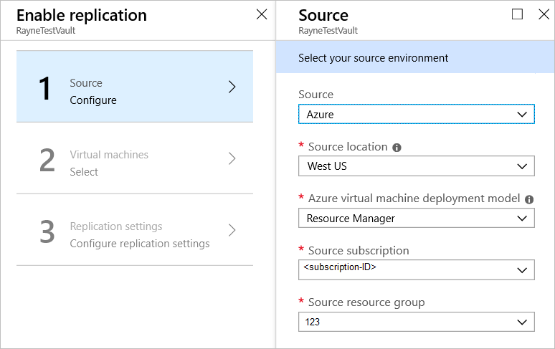

### Select the VMs

Site Recovery retrieves a list of the VMs associated with the subscription and resource group/cloud service.

1. In **Virtual Machines**, select the VMs you want to replicate.
2. Click **OK**.

### Configure replication settings

Site Recovery creates default settings and replication policy for the target region. You can change the settings as required.

1. Click **Settings** to view the target and replication settings.
2. To override the default target settings, click **Customize** next to **Resource group, Network, Storage and Availability**.
3. Customize target settings as summarized in the table.

| **Setting** | **Details** |
| --- | --- |
| **Target subscription** | By default, the target subscription is the same as the source subscription. Click 'Customize' to select a different target subscription within the same Azure Active Directory tenant. |
| **Target location** | The target region used for disaster recovery.  We recommend that the target location matches the location of the Site Recovery vault. |
| **Target resource group** | The resource group in the target region that holds Azure VMs after failover.  By default, Site Recovery creates a new resource group in the target region with an "asr" suffix. The location of the target resource group can be any region except the region in which your source virtual machines are hosted. |
| **Target virtual network** | The network in the target region that VMs are located after failover.  By default, Site Recovery creates a new virtual network (and subnets) in the target region with an "asr" suffix. |
| **Cache storage accounts** | Site Recovery uses a storage account in the source region. Changes to source VMs are sent to this account before replication to the target location.  If you are using a firewall-enabled cache storage account, make sure that you enable **Allow trusted Microsoft services**. [Learn more.](https://docs.microsoft.com/azure/storage/common/storage-network-security#exceptions) |
| **Target storage accounts (source VM uses non-managed disks)** | By default, Site Recovery creates a new storage account in the target region to mirror the source VM storage account.  Enable **Allow trusted Microsoft services** if you're using a firewall-enabled cache storage account. |
| **Replica managed disks (If source VM uses managed disks)** | By default, Site Recovery creates replica managed disks in the target region to mirror the source VM's managed disks with the same storage type (Standard or premium) as the source VM's managed disk. You can only customize Disk type |
| **Target availability sets** | By default, Azure Site Recovery creates a new availability set in the target region with name having "asr" suffix for the VMs part of an availability set in source region. In case availability set created by Azure Site Recovery already exists, it is reused. |
| **Target availability zones** | By default, Site Recovery assigns the same zone number as the source region in target region if the target region supports availability zones.  If the target region doesn't support availability zones, the target VMs are configured as single instances by default.  Click **Customize** to configure VMs as part of an availability set in the target region.  You can't change the availability type (single instance, availability set or availability zone) after you enable replication. You need to disable and enable replication to change the availability type. |

1. To customize replication policy settings, click **Customize** next to **Replication policy**, and modify the settings as needed.

| **Setting** | **Details** |
| --- | --- |
| **Replication policy name** | Policy name. |
| **Recovery point retention** | By default, Site Recovery keeps recovery points for 24 hours. You can configure a value between 1 and 72 hours. |
| **App-consistent snapshot frequency** | By default, Site Recovery takes an app-consistent snapshot every 4 hours. You can configure any value between 1 and 12 hours.  An app-consistent snapshot is a point-in-time snapshot of the application data inside the VM. Volume Shadow Copy Service (VSS) ensures that app on the VM are in a consistent state when the snapshot is taken. |
| **Replication group** | If your application needs multi-VM consistency across VMs, you can create a replication group for those VMs. By default, the selected VMs are not part of any replication group. |

1. In **Customize**, select **Yes** for multi-VM consistency if you want to add VMs to a new or existing replication group. Then click **OK**.

### Configure encryption settings

If the source VM has Azure disk encryption (ADE) enabled, review the settings.

1. Verify the settings:
   * **Disk encryption key vaults**: By default, Site Recovery creates a new key vault on the source VM disk encryption keys, with an "asr" suffix. If the key vault already exists, it is reused.
   * **Key encryption key vaults**: By default, Site Recovery creates a new key vault in the target region. The name has an "asr" suffix, and is based on the source VM key encryption keys. If the key vault created by Site Recovery already exists, it's reused.
2. Click **Customize** to select custom key vaults.

### Track replication status

1. In **Settings**, click **Refresh** to get the latest status.
2. Track progress and status as follows:
   * Track progress of the **Enable protection** job in **Settings** > **Jobs** > **Site Recovery Jobs**.
   * In **Settings** > **Replicated Items**, you can view the status of VMs and the initial replication progress. Click the VM to drill down into its settings.

# Run a disaster recovery drill for Azure VMs to a secondary Azure region

The [Azure Site Recovery](https://docs.microsoft.com/en-us/azure/site-recovery/site-recovery-overview) service contributes to your business continuity and disaster recovery (BCDR) strategy by keeping your business apps up and running available during planned and unplanned outages. Site Recovery manages and orchestrates disaster recovery of on-premises machines and Azure virtual machines (VMs), including replication, failover, and recovery.

This tutorial shows you how to run a disaster recovery drill for an Azure VM, from one Azure region to another, with a test failover. A drill validates your replication strategy without data loss or downtime, and doesn't affect your production environment. In this tutorial, you learn how to:

* Check the prerequisites
* Run a test failover for a single VM

## Prerequisites

* Before you run a test failover, we recommend that you verify the VM properties to make sure everything's as expected. Access the VM properties in **Replicated items**. The **Essentials** blade shows information about machines settings and status.
* **We recommend you use a separate Azure VM network for the test failover**, and not the default network that was set up when you enabled replication.
* Depending on your source networking configurations for each NIC, you can optionally specify **subnet, IP address, Public IP, Network Security Group or Internal Load Balancer** to attach to each NIC under test failover settings in Compute & Network prior to conducting DR drill.

## Run a test failover

1. In **Settings** > **Replicated Items**, click the VM **+Test Failover** icon.
2. In **Test Failover**, Select a recovery point to use for the failover:
   * **Latest**: Processes all the data in Site Recovery and provides the lowest RTO (Recovery Time Objective).
   * **Latest processed**: Fails the VM over to the latest recovery point that was processed by Site Recovery. The time stamp is shown. With this option, no time is spent processing data, so it provides a low RTO (Recovery Time Objective)
   * **Latest app-consistent**: This option fails over all VMs to the latest app-consistent recovery point. The time stamp is shown.
   * **Custom**: Fail over to particular recovery point. Custom is only available when you fail over a single VM, and not for failover with a recovery plan.
3. Select the target Azure virtual network to which Azure VMs in the secondary region will be connected, after the failover occurs.
4. To start the failover, click **OK**. To track progress, click the VM to open its properties. Or, you can click the **Test Failover** job in the vault name > **Settings** > **Jobs** > **Site Recovery jobs**.
5. After the failover finishes, the replica Azure VM appears in the Azure portal > **Virtual Machines**. Make sure that the VM is running, sized appropriately, and connected to the appropriate network.
6. To delete the VMs that were created during the test failover, click **Cleanup test failover** on the replicated item or the recovery plan. In **Notes**, record and save any observations associated with the test failover.

# Fail over and reprotect Azure VMs between regions

This tutorial describes how to fail over an Azure virtual machine (VM) to a secondary Azure region with the [Azure Site Recovery](https://docs.microsoft.com/en-us/azure/site-recovery/site-recovery-overview) service. After you've failed over, you reprotect the VM. In this tutorial, you learn how to:

* Fail over the Azure VM
* Reprotect the secondary Azure VM, so that it replicates to the primary region.

## Prerequisites

* Before you start, review [frequently asked questions](https://docs.microsoft.com/en-us/azure/site-recovery/site-recovery-faq#failover) about failover.
* Make sure that you've completed a [disaster recovery drill](https://docs.microsoft.com/en-us/azure/site-recovery/azure-to-azure-tutorial-dr-drill) to check everything is working as expected.
* Verify the VM properties before you run the test failover. The VM must comply with [Azure requirements](https://docs.microsoft.com/en-us/azure/site-recovery/azure-to-azure-support-matrix#replicated-machine-operating-systems).

## Run a failover to the secondary region

1. In **Replicated items**, select the VM that you want to fail over > **Failover**

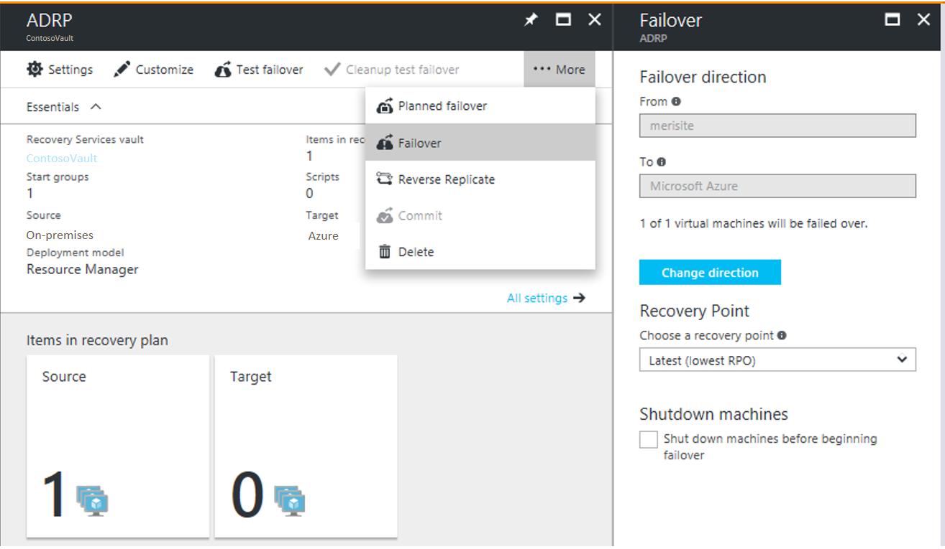

1. In **Failover**, select a **Recovery Point** to fail over to. You can use one of the following options:
   * **Latest** (default): Processes all the data in the Site Recovery service and provides the lowest Recovery Point Objective (RPO).
   * **Latest processed**: Reverts the virtual machine to the latest recovery point that has been processed by Site Recovery service.
   * **Custom**: Fails over to a particular recovery point. This option is useful for performing a test failover.
2. Select **Shut down machine before beginning failover** if you want Site Recovery to attempt to do a shutdown of source VMs before triggering the failover. Shutdown helps to ensure no data loss. Failover continues even if shutdown fails. Site Recovery does not clean up the source after failover.
3. Follow the failover progress on the **Jobs** page.
4. After the failover, validate the virtual machine by logging in to it. If you want to go another recovery point for the virtual machine, then you can use **Change recovery point** option.
5. Once you are satisfied with the failed over virtual machine, you can **Commit** the failover. Committing deletes all the recovery points available with the service. You won't now be able to change the recovery point.

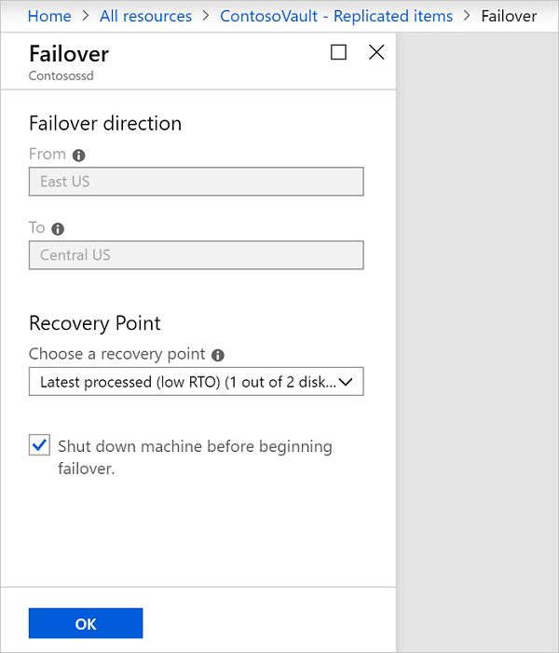

## Reprotect the secondary VM

After failover of the VM, you need to reprotect it so that it replicates back to the primary region.

1. Make sure that the VM is in the **Failover committed** state, and check that the primary region is available, and you're able to create and access new resources in it.
2. In **Vault** > **Replicated items**, right-click the VM that's been failed over, and then select **Re-Protect**.

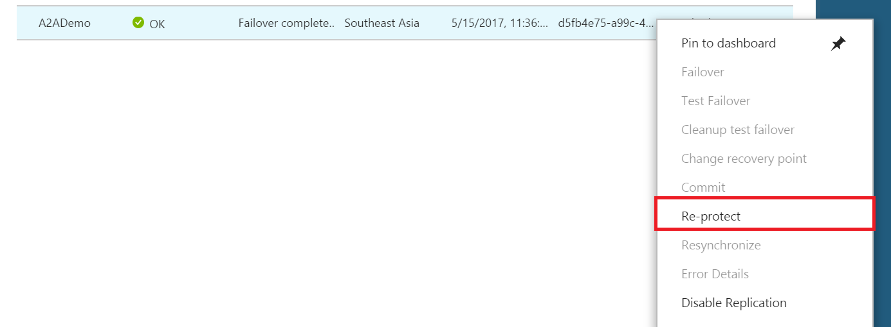

1. Verify that the direction of protection, secondary to primary region, is already selected.
2. Review the **Resource group, Network, Storage, and Availability sets** information. Any resources marked as new are created as part of the reprotect operation.
3. Click **OK** to trigger a reprotect job. This job seeds the target site with the latest data. Then, it replicates the deltas to the primary region. The VM is now in a protected state.